
Bangalore Institute of Technology
K.R. ROAD, BENGALURU-560004.
Department of Computer Science and Engineering

DBMS Mini Project Synopsis

Student Result Management System

USN | NAME | BATCH | PHONE NO | E-MAIL
1BI19CS038 | Bharath Gowda B | A2 | 9900783185 | bharathvishnubharath@gmail.com
1BI19CS058 | Harish V | A4 | 9880948479 | harish00411@gmail.com

Problem Domain: Education
Lab In-Charges: Prof. Prathima M.G, Prof. Kavitha K

29-12-2021
2021-2022

For office use only:

Accepted :

To be modified :

Rejected :

Signature of the Lab In-Charges
PROBLEM STATEMENT:
“To design and develop a system for managing the results of students.”
This system is built for students to check results and gather information about courses offered by department. The faculty can view the overall performance of the students in the semester examinations subject-wise. The student accessing their results through college site is more convenient and the faculty can easily analyse pass and fail of a particular subject. This system is built to check marks for different semester.

FRONT-END TOOL:
- HTML
- CSS
- JAVASCRIPT
- BOOTSTRAP5

HTML: HTML is the standard markup language for documents designed to be displayed in a web browser.
CSS: Cascading Style Sheets is a style sheet language used for describing the presentation of a document written in a markup language such as HTML.
JAVASCRIPT: JavaScript is a powerful and flexible programming language. It can execute on a web browser that allows us to make interactive webpages.
BOOTSTRAP5: Bootstrap is a free and open-source CSS framework directed at responsive, mobile-first front-end web development.
BACK-END TOOL:
- Python
- NodeJS
- Oracle

Python: Python is a general-purpose interpreted, interactive, object-oriented, and high-level programming language.
NodeJS: Node.js is an open-source, cross-platform, back-end JavaScript runtime environment that runs on the V8 engine and executes JavaScript code outside a web browser.
Oracle: Oracle is a relational database management system based on the Structured Query Language, which is the popular language for accessing and managing the records in the database.
ER-Diagram:

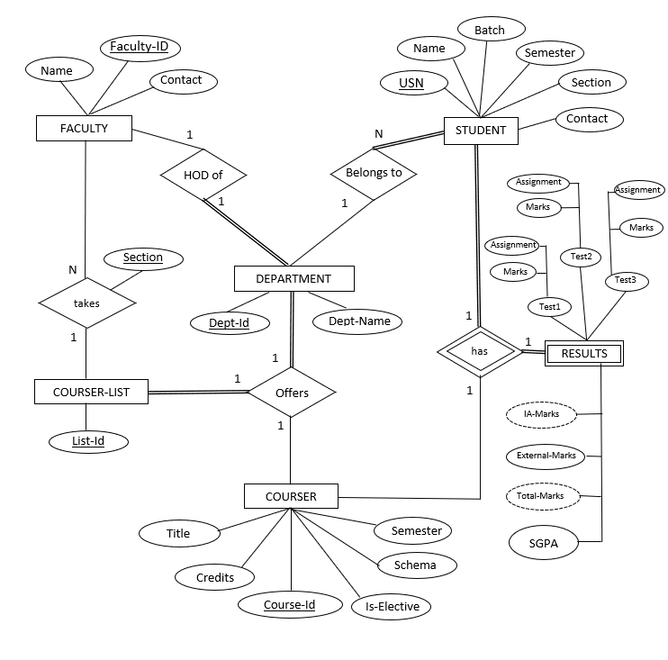

ER to Relational mapping:

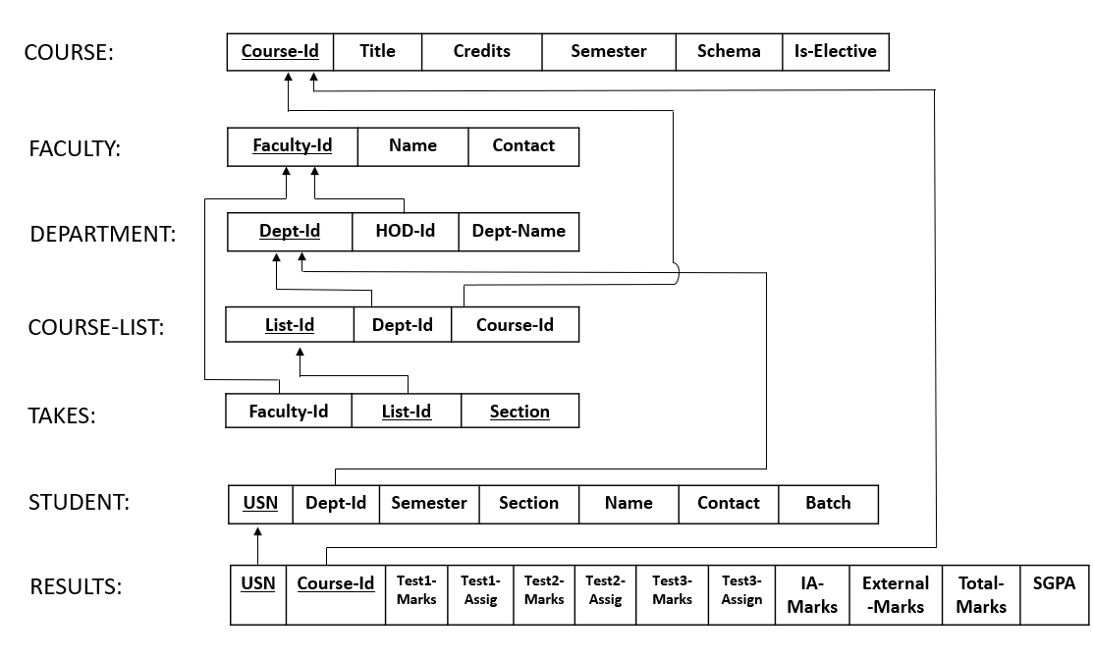

NORMALIZATION:

- FACULTY:

Faculty-Id | Name | Contact
F100 | Shobha | 9900783185
F101 | Kiran | 9988075452
F102 | Yashwanth | 9986451235
F103 | Kishor | 7844561540
F104 | Suma | 9845540044

  - FD = {Faculty-Id → {Name, Contact}}
  - The FACULTY relation is in 1NF since all columns have atomic and unique values.
  - The relation is in 2NF since every nonprime attribute in FACULTY is fully functionally dependent on the primary key Faculty-Id.
  - None of the non-prime attribute of FACULTY is transitively dependent on the primary key. So, it is in 3NF.

- COURSE:
Couse-Id | Title | Credits | Semester | Schema | Is-Elective
18MAT11 | Math-I | 4 | 1 | 2018 | 0 (False)
18CS54 | ATCI | 3 | 5 | 2018 | 0 (False)
18CS641 | Advance-Java | 3 | 6 | 2018 | 1 (True)
18CS642 | Image-Processing | 3 | 6 | 2018 | 1 (True)
18EE78 | Adv-Electronics | 3 | 7 | 2018 | 0 (False)

- FD = {Course-Id → {Title, Credits, Semester, Schema, Is-Elective}}
  - The COURSE relation is in 1NF since all columns have atomic and unique values.
  - The relation is in 2NF since every nonprime attribute in COURSE is fully functionally dependent on the primary key Course-Id.
  - None of the non-prime attribute of COURSE is transitively dependent on the primary key. So, it is in 3NF.

- Consider coursers offered by a department including faculty in-charge for each course:
- Department-Course-List: ( R )
List-Id | Dept-Id | Dept-Name | Hod-Id | Course-Id | Faculty-Id | Section
L100 | D100 | CSE | F100 | 18CS54 | F102 | A
L100 | D100 | CSE | F100 | 18CS54 | F102 | B
L101 | D100 | CSE | F100 | 18CS641 | F103 | A
L102 | D100 | CSE | F100 | 18MAT11 | F104 | A
L103 | D101 | EEE | F101 | 18MAT11 | F104 | A
L104 | D101 | EEE | F101 | 18EE78 | F101 | A
L104 | D101 | EEE | F101 | 18EE78 | F101 | B

FD: {
List-Id → {Dept-Id, Course-Id}
Dept-Id → {Dept-Name, Hod-Id}
{List -Id, Section} → Faculty-Id
}
Candidate key:
{List-Id, Section}⁺ = {Dept-Id, Dept-Name, Hod-Id, Course-ID, Faculty-Id}
Prime Attribute: {List-Id, Section}
Non-Prime Attribute: {Dept-Id, Dept-Name, Hod-Id, Course-ID, Faculty-Id}
  - The given relation R is in 1NF since all columns have atomic and unique values.
  - The relation is not in 2NF since Dept-Id and Course-Id is dependent only on List-Id which is a proper subset of Candidate Key.
  - Divide the Relation into two relations, one Department-Courses((List-Id, Course-Id, Dept-Id, Dept-Name, Hod-Id), another one Faculty-Takes(Faculty-Id, List-Id, Section}

DEPARTMENT-COURSE:
List-Id | Course-Id | Dept-Id | Dept-Name | Hod-Id
L100 | 18CS54 | D100 | CSE | F100
L101 | 18CS641 | D100 | CSE | F100
L102 | 18MAT11 | D100 | CSE | F100
L103 | 18MAT11 | D101 | EEE | F101
L104 | 18EE78 | D101 | EEE | F101
  - The relation is in 2NF since every nonprime attribute is fully functionally dependent on the primary key List-Id.
  - The non-prime attribute Dept-Name and Hod-Id are transitively dependent on List-Id. Hence the relation is not in 3NF
  - Divide the Relation into two relations, one Department(Dept-Id, Dept-Name, Hod-Id) another one Courses-List(List-Id, Course-Id, Dept-Id,}

DEPARTMENT:
Dept-Id | Dept-Name | Hod-Id
D100 | CSE | F100
D101 | EEE | F101
- None of the non-prime attribute of DEPARTMENT is transitively dependent on the primary key. So, it is in 3NF.
COURSE-LIST:
List-Id | Dept-Id | Course-Id
L100 | 18CS54 | D100
L101 | 18CS641 | D100
L102 | 18MAT11 | D100
L103 | 18MAT11 | D101
L104 | 18EE78 | D101
- None of the non-prime attribute of STUDENT is transitively dependent on the primary key. So, it is in 3NF.
FACULTY-TAKES:
Faculty-Id | List-Id | Section
F102 | L100 | A
F102 | L100 | B
F103 | L101 | A
F104 | L102 | A
F104 | L103 | A
F101 | L104 | A
F101 | L104 | B
- None of the non-prime attribute of FACULTY_TAKES is transitively dependent on the primary key. So, it is in 3NF.
- STUDENT:
USN | Name | Contact | Dept-Id | Batch | Semester | Section
1BI18CS001 | Girish | 9988775461 | D100 | 2018 | 7 | A
1BI19CS002 | Vivek | 9845678541 | D100 | 2019 | 5 | A
1BI19CS058 | Hairsh | 9655874575 | D100 | 2019 | 5 | B
1BI19CS161 | Suyog | 6988450210 | D101 | 2019 | 5 | B

  - The STUDENT relation is in 1NF since all columns have atomic and unique values.
  - The relation is in 2NF since every nonprime attribute in STUDENT is fully functionally dependent on the primary key USN.
  - None of the non-prime attribute of STUDENT is transitively dependent on the primary key. So, it is in 3NF.

- RESULTS:
USN | Course-Id | Test-1  Marks | Test-I  Ass.M | Test-2  Marks | .. | IA  Marks | External  Marks | Total  Marks | SGPA  Points
1BI19CS002 | 18MAT11 | 30 | 10 | 30 |  | 40 | 49 | 89 | 36
1BI19CS002 | 18CS54 | 29 | 8 | 25 |  | 35 | 45 | 80 | 27
1BI19CS058 | 18CS54 | 30 | 10 | 28 |  | 38 | 48 | 86 | 27
1BI19CS161 | 18MAT11 | 25 | 7 | 20 |  | 38 | 50 | 88 | 36
1BI19CS161 | 18EE78 | 15 | 8 | 25 |  | 30 | 35 | 75 | 24

  - The RESULTS relation is in 1NF since all columns have atomic and unique values.
  - The relation is in 2NF since every nonprime attribute in RESULTS is fully functionally dependent on the primary key (USN, Course-Id).
  - None of the non-prime attribute of RESULTS is transitively dependent on the primary key. So, it is in 3NF.

MODULE DESCRIPTION:

- Admin:
  - Admin has complete access to all the resources. Admin creates new users (like faculty, student), update details of the user. Any complex operations required are done by admin.

- Faculty:
  - Login: Faculty can be both teaching and non-teaching staff. Admin creates account for new faculty and provides them with user-id and password. Faculty can login into portal using the same.
  - Course-taken: Faculty can take different course to different classes, Course-taken module gives details about it.
  - Update-Marks: This module allows a Faculty to retrieve, update marks of each students in a particular test. The output of this module will be in table form.
  - CSV-Operation: This module allows a Faculty to export results of student in csv format. Which can be opened in Excel for any further operations. Faculty can import a csv file to update marks as long as the file follows required constraints.
  - Maths-Operation: This module allows a Faculty to use simple math operations (like addition, subtraction, average) for updating marks. Ex. Operation to find the final internal marks based on three tests average.

- Department:
  - HOD: For each department there is one Faculty as HOD. This module allows the HOD to monitor other faculties working for the department.
  - Course-Offered: The HOD can add or remove courses offered by the department for a particular semester based on university schema.

- Student:
  - Login: Student can use there USN (or any Unique ID provided by the Institution) and password distributed by admin as user credentials.
  - Check-Result: This module allows the Students to check their marks (updated by faculty in-charge). Students can also check their previous semester results.
  - Contact-Faculty: This module connects Student with faculty in-charge for any querying. Student can only contact the faculty in-charge of a particular course in current semester of the student.

APPLICATIONS:
- Collage result portal.

- Manage students result in school.

- Export Results as CSV file.

- Can be used to derive Student Management System

